**5.1 Installing driver**

1. We connect the game console to the computer with a USB cable. When the computer detects the hardware, we open the device manager, as shown below.

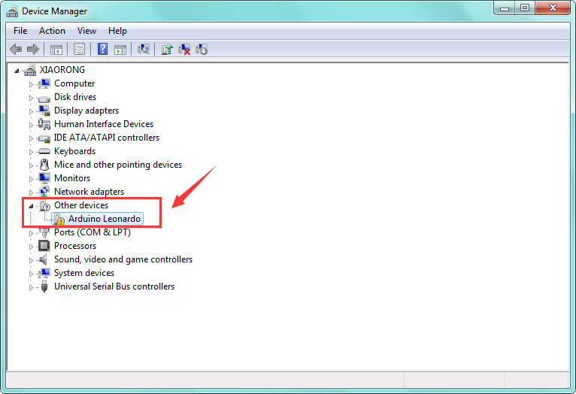

1. Double click on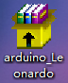driver file, click “next step”, driver starts installing automatically.
2. Install driver successfully，open the device manager, as shown below.

